F

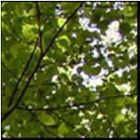
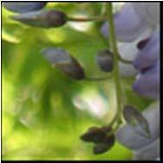
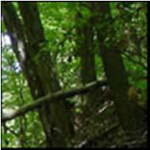
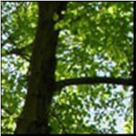
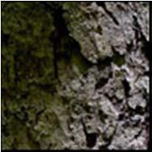
ASHLEY SCHIFF PRESERVE SCHOLARSHIP
Stony Brook University

Dr. Ashley Schiff was a dedicated and popular Associate Professor of Political Science and an avowed naturalist in the early days of Stony Brook University. In the fall of 1969, he died suddenly and unexpectedly at the age of 37. A 26-acre woodland located on campus, lined with oak and maple trees, was dedicated in his memory by the former U.S. Interior Secretary Stewart Udall and SUNY Stony Brook President John S. Toll in 1970.

A rich variety of plants and animals can be found in the forest. A number of these plants are vulnerable native species under threat from development in many parts of the state. Animals such as garter snakes, Virginia opossums, and box turtles are known to live there. More information about Dr. Schiff, as well as the creation of the preserve can be found at www.ashleyschiff.org.

The Ashley Schiff Preserve Scholarship (ASPS) recognizes Stony Brook University undergraduate and graduate students of outstanding academic ability who demonstrate a commitment to environmental preservation through academic studies, research, music or art. This scholarship (up to $1,000 awarded annually) was established in 2006 by the Friends of the Ashley Schiff Preserve (FASP) through a generous donation by Avalon Park & Preserve, Inc. to honor the memory of Dr. Ashley Schiff.

Scholarship Qualifications for Applicants

A. Must be a full-time Stony Brook student the year the scholarship is in effect. B. Must be a Junior, Senior, or Graduate student with a strong interest in the natural environment.
C. Must have a minimum 3.0 GPA.
D. Must demonstrate leadership, potential, and promise.

In addition, the ASPS Selection Committee seeks applicants that demonstrate:

o a passion and capacity to exercise leadership and respond to social and environmental challenges;
o a commitment to the values of diversity and justice within the environmental field;
o The desire to remain an active member of the Friends of Ashley Schiff
Preserve (FASP) after the conclusion of their education at Stony Brook University.

o Please keep in mind that the scholarship is not limited to a research paper or research project. Art, music, creative writing and political science projects are highly encouraged.

Scholarship Selection

A. Applications for the 2025-2026 award are due by Friday, November 13, 2026.
Applicants will be notified by December 4 if they are chosen.

B. Selection for funding will be made by the scholarship subcommittee of the Friends Advisory Committee and the student(s) will be notified by the committee chair if their proposal is accepted.

C. Scholarship recipients will be required to give a 5-10 minute presentation of their project to the Advisory Board of the Friends of the Ashley Schiff Preserve in the Spring of 2027.

D. Scholarship recipients are encouraged to attend the annual FASP Friendraiser in November 2027 to be honored for their completed project. They should provide a single power point slide outlining their project for presentation at the November 2027 Friendraiser.

E. The award will be presented to the recipient in one payment, upon the successful completion of the project.

F. Award recipients must be in student status and maintain a GPA above 3.0 in the Spring 2027 semester. The award recipient must be in student status in order for the award to be paid out.

Scholarship Directions (Three Parts)

Part I:

A. Submit a cover letter and a 1-2 page prospectus that clearly describes your project and how the Ashley Schiff Preserve will be used in support of this project or research. What will be the end product of your project or research? (usually a report, a manuscript, a thesis, or a work of art or music)
(Please note that current credit-bearing research and internships are eligible for
this scholarship).

B. Obtain at least one letter of reference from a sponsoring professor, mentor, or research supervisor in support of your application.

C. Attach a current SBU transcript. If you are awarded the scholarship, it will be necessary for you to be enrolled in a for-credit research or internship course and have secured a faculty mentor. Such courses, with variable credit, are offered through many departments.

Part II: Ashley Schiff Preserve Scholarship Application

Name /_ /

First Middle Last

Current Full Mailing Address

Home phone ( ) Cell phone ( )_

Stony Brook ID #

E-mail address

Major(s) at Stony Brook University

Field(s) of interest that you expect to pursue

Anticipated completion date of research

Applicant Signature Date

Part III: To be completed by sponsoring professor, mentor, or research supervisor.
I am aware that will participate in the activities described in his/her research proposal and that the applicant demonstrates the ability and motivation to see
the project to completion as required by this scholarship. If the student is awarded the ASPS, I am willing to be the student’s advisor for the duration of this project and to attend the scholarship awarding ceremony.

Name (please print)

Signature

Department Date

Please submit all documentation in electronic form to:
Friends of Ashley Schiff Preserve Attn: Melissa Cohen Melissa.J.Cohen@stonybrook.edu

